SLO Form Instructions
Beginning of the Year Steps for SLO Form

Step 1: Go to the SLO Website: http://learning.jordandistrict.org/

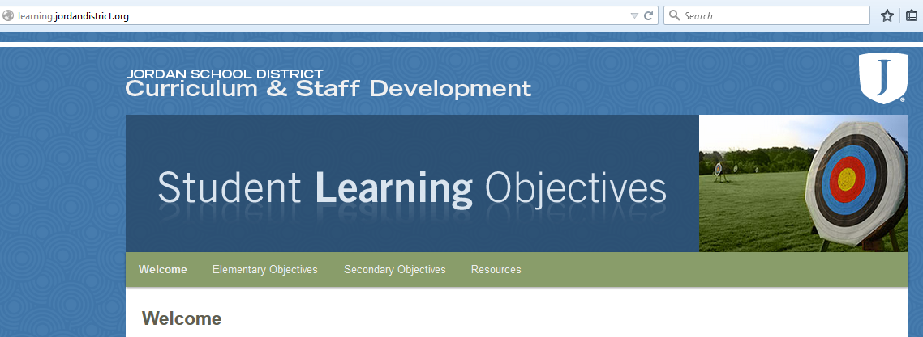

Step 2: Select either “Elementary Objectives” for the elementary SLO forms (Language Arts, Math, or Science), or select “Secondary Objectives” for the secondary subject area SLO forms (the forms are organized alphabetically by subject area). Enter the password for the site.

Step 3: Download the appropriate form. Find where downloads go on your computer and open the document.

Step 4: Write your name in the box titled “Classroom Teacher Name.” The rest of the necessary boxes already contain the appropriate information. Some boxes in this section may be left blank. Save this document on your computer. You will need to refer to this document throughout the year. 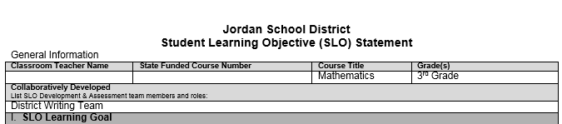

Step 5: Read over the following sections: I. SLO Learning Goal, II. Teacher SLO Implementation Plan, and III. Assessment of SLO.

Step 6: Give the pre-assessment using MasteryConnect. For step-by-step instructions on how to use MasteryConnect go to the resources tab on the SLO website: http://learning.jordandistrict.org/resources/. If you need additional assistance, contact your district assigned curriculum technology specialist.

Make sure that you are within the testing window. For information regarding testing window dates, refer to the monthly testing bulletin published by the Evaluation, Research, and Accountability Department: http://assessments.jordandistrict.org/bulletin/.

Step 7: On your saved SLO form go to section “IV Classroom Assessment Data” box A. In the future, you will be able to use your SLO information from previous years. If your class is a tested subject or grade, you can use SAGE data in addition to your SLO data. You can also include historical data and trends from your own classroom assessments. Complete this box using any pertinent data.

Step 8: Move on to box B in section IV. Based on your pre-assessment data from the SLO Growth Worksheet (see instructions below), set and record goals for how you will help your students obtain the necessary minimal growth. Analyze and record the test results so that you can identify focus areas for your students. Plan lessons to cover the concepts and skills that are critical needs for your students.

Step 9: Save what you have completed so far. At the end of the year, you will complete box C.

Beginning of Year SLO Growth Worksheet Instructions

Step 1: Go to the resources tab of the SLO website: http://learning.jordandistrict.org/resources/ . Click on the SLO Test Growth Worksheet (multiple choice and/or short answer tests) and it will download the document. Click on the SLO Rubric Worksheet (performance based assessments) and it will download the document. Find where downloads go on your computer and open the document.

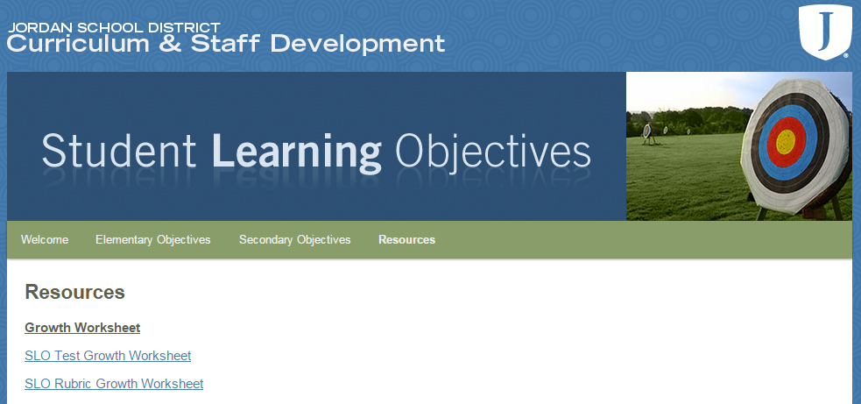

Step 2: Fill in the following fields: Teacher’s Last Name, Teacher’s First Name, Teacher’s Cactus ID, Class Period/Subject, Test Name, School Name, School ID number, and School Year. Save this document to a location that can easily be accessed later in the year. Leave this document open as you follow the next few steps.

To find your school’s ID number go to the Jordan District homepage: http://jordandistrict.org/. Under the “Faculty & Staff” tab, click “Directories.” Under “School Directories,” click “School Directory.” The small number to the left of the school name is the school ID number.
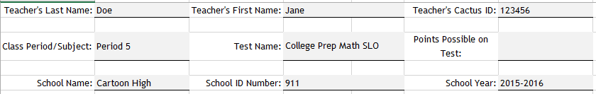
Step 3: Log in to MasteryConnect (https://www.masteryconnect.com/). Go to the tracker of the class that has been chosen for your SLO. Find the corresponding SLO assessment column in your tracker (it should be dark gray). Hover over the SLO assessment name and a drop-down menu will appear below. Click on “Assess.”

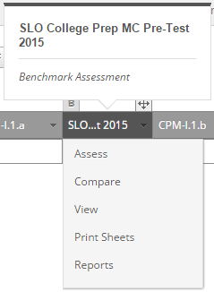

Step 4: Hover over the orange menu button and a drop-down menu will appear. Click on “Export to Excel.”

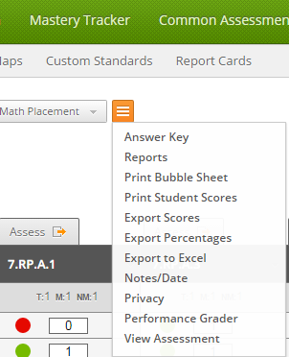

Step 5: An “Export Options” menu will appear. Uncheck “Show answers for each item” and check “Show percentages for each score.”

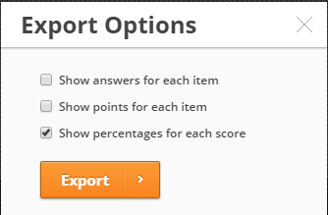

Click on the orange “Export” button. This will place a copy of the spreadsheet in your download folder. Find where downloads go on your computer and open the document.
Step 6: Select the information in the first three columns by highlighting those fields. Do not include the title of the column. Copy the information by pressing the command and c keys for MAC users or the ctrl and c keys for PC users. Leave this document open while you go to the SLO Growth Worksheet. Click in the first cell under the Student ID column and paste the information in the first three columns by pressing the command and v keys or the ctrl and v keys.

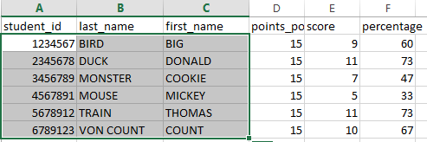

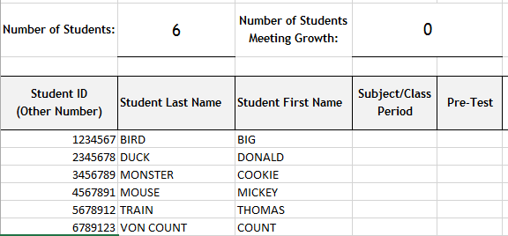

Step 7: Using the “points possible” column from the exported MasteryConnect data document, fill in the “Points Possible on Test” or “Highest Level on Rubric” field on the SLO Growth Worksheet.

Next, fill in the column titled “Subject/Class Period” with the subject (ELA, math, or science) for elementary or the class period for secondary. Save the document.

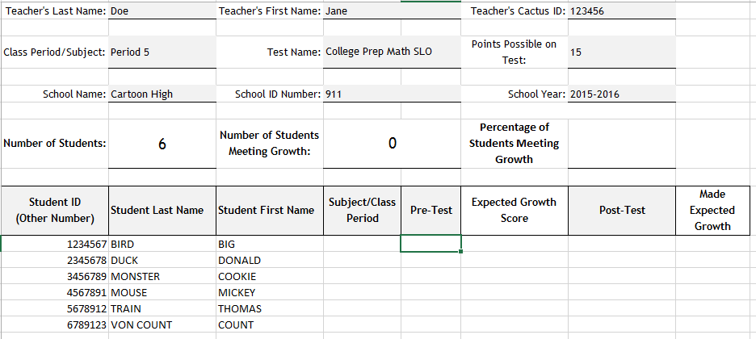

Step 8: Go back to the exported MasteryConnect data document that was left open. Select the pre-test scores by highlighting the information in the “score” column. Do not include the title of the column. Copy the information by pressing the command and c keys for MAC users or the ctrl and c keys for PC users. Leave this document open while you go to the SLO Growth Worksheet.

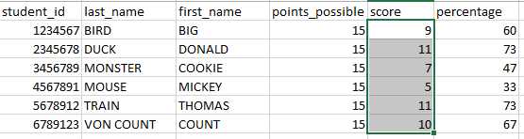

Click in the first cell under the “Pre-Test” column and paste the information in the column by pressing the command and v keys or the ctrl and v keys. The expected growth score will automatically be calculated. Save this document.

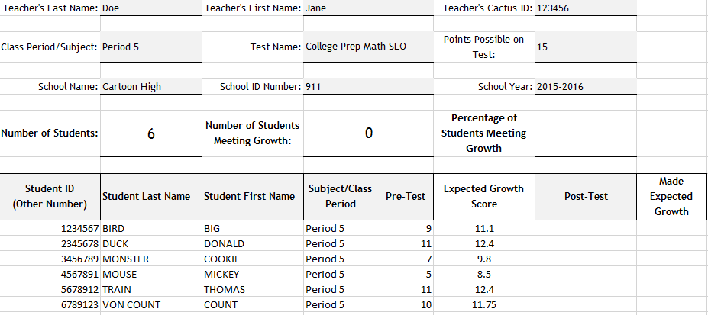

End of Year SLO Growth Worksheet Instructions

Step 1: Find your SLO Growth Worksheet that was saved to your computer. Open the document. Delete any students who did not take the post-assessment.

For Mac users, click on the last name of the student you would like to delete. Then, select the “Edit” drop-down menu then click delete. Choose “entire row” to delete all of the student’s information.

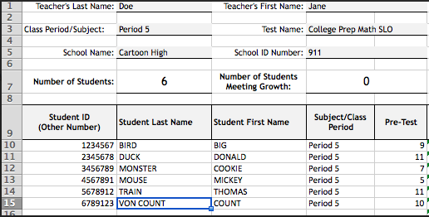

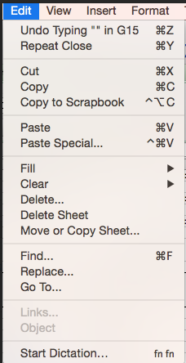 | 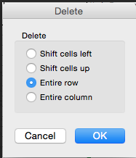

For PC users, with your mouse right click on the row number. Then select “Delete.”
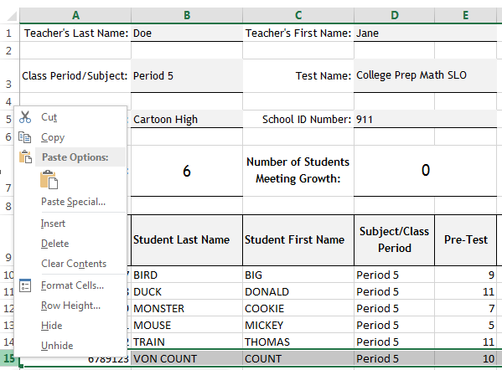

Step 2: Log in to MasteryConnect (https://www.masteryconnect.com/). Go to the tracker of the class that has been chosen for your SLO. Find the corresponding SLO assessment column in your tracker (it should be a dark gray). Hover over the SLO assessment name and a drop-down menu will appear below. Click on “Assess.”

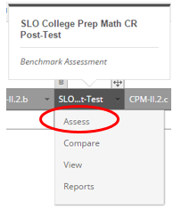

Step 3: Hover over the orange menu button and a drop-down menu will appear. Click on “Export to Excel.”

Step 4: An Export Options Menu will appear. Uncheck “Show answers for each item” and check “Show percentages for each score.” Click on the orange “Export” button. This will place a copy of the spreadsheet in your download folder. Find where downloads go on your computer and open the document.

Step 5: Select the post-test scores by highlighting the information in the score column. Do not include the title of the column. Copy the information by pressing the command and c keys for MAC users or the ctrl and c keys for PC users. Leave this document open while you go to the SLO Growth Worksheet.

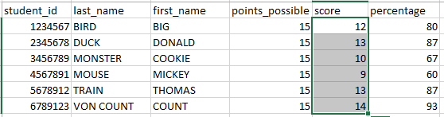

Click in the first cell under the “Post-Test” column and paste the information in the column by pressing the command and v keys or the ctrl and v keys. The percentage of students meeting growth will automatically be calculated. Save this document to a location that can easily be accessed later in the year. E-mail this document to Holly Allen (holly.allen@jordandistrict.org) in the Evaluation, Research, and Accountability Department.

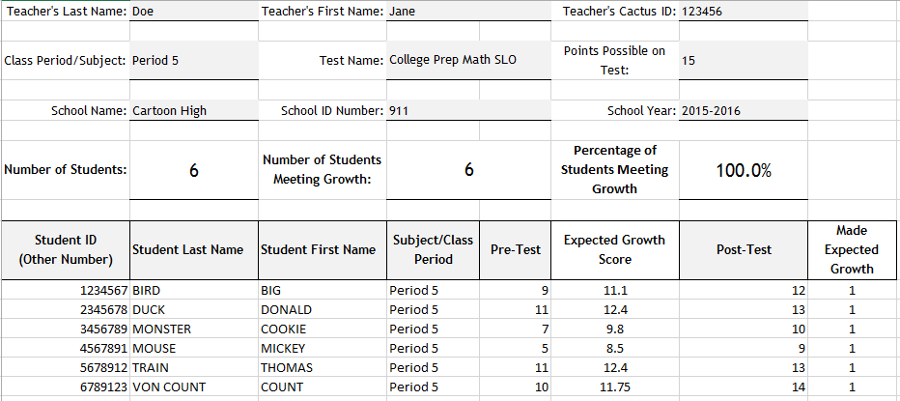

End of the Year Steps for SLO Form

Step 1: Open your SLO Form that was previously saved to your computer. Go to section “IV Classroom Assessment Data” box C. Record the percentage of students who achieved the growth goal as reported in the SLO Growth Worksheet. Reflect on student progress.

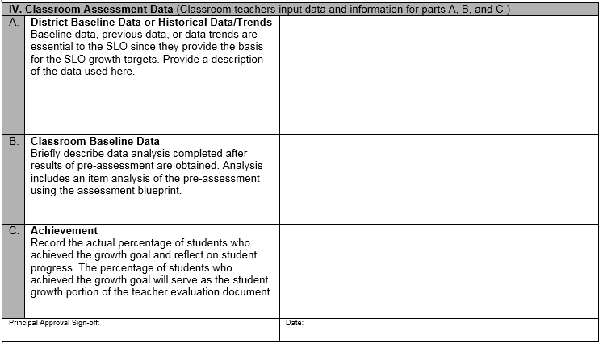

Step 2: Have your principal sign and date to approve the completed form. Principals will need to keep a copy of the completed and signed form in the teacher’s evaluation file.

